October 10, 2022

**BCS203193**

MUHAMMAD HARRIS – SECTION 4

Computer Organization & Assembly Language LAB

LAB 03 Practice Task

Practice Task

# Task 01

**Add two numbers and show their ASCII number or representation? (Hint: Do not convert ASCII to decimal by adding 48.)**

## Answer:

.model small

.data

str1 db "Enter a Number: $"

str2 db 0ah,0dh,"Enter another Number: $"

str3 db 0ah,0dh,"Result: $"

.code

;moving data to data segment

mov ax, @data

mov ds, ax

;printing str1

mov ah, 09

mov dx, offset str1

int 21h

;take input

mov ah, 01

int 21h

;moving input value to bl register

mov bl, al

;printing str2

mov ah, 09

mov dx, offset str2

int 21h

;take input

mov ah, 01

int 21h

;moving input to cl resgister

mov cl, al

;adding cl to bl

add bl, cl

;printing str3

mov ah, 09

mov dx, offset str3

int 21h

;moving result to dl resiter

mov dl,bl

;printing result

mov ah, 02

int 21h

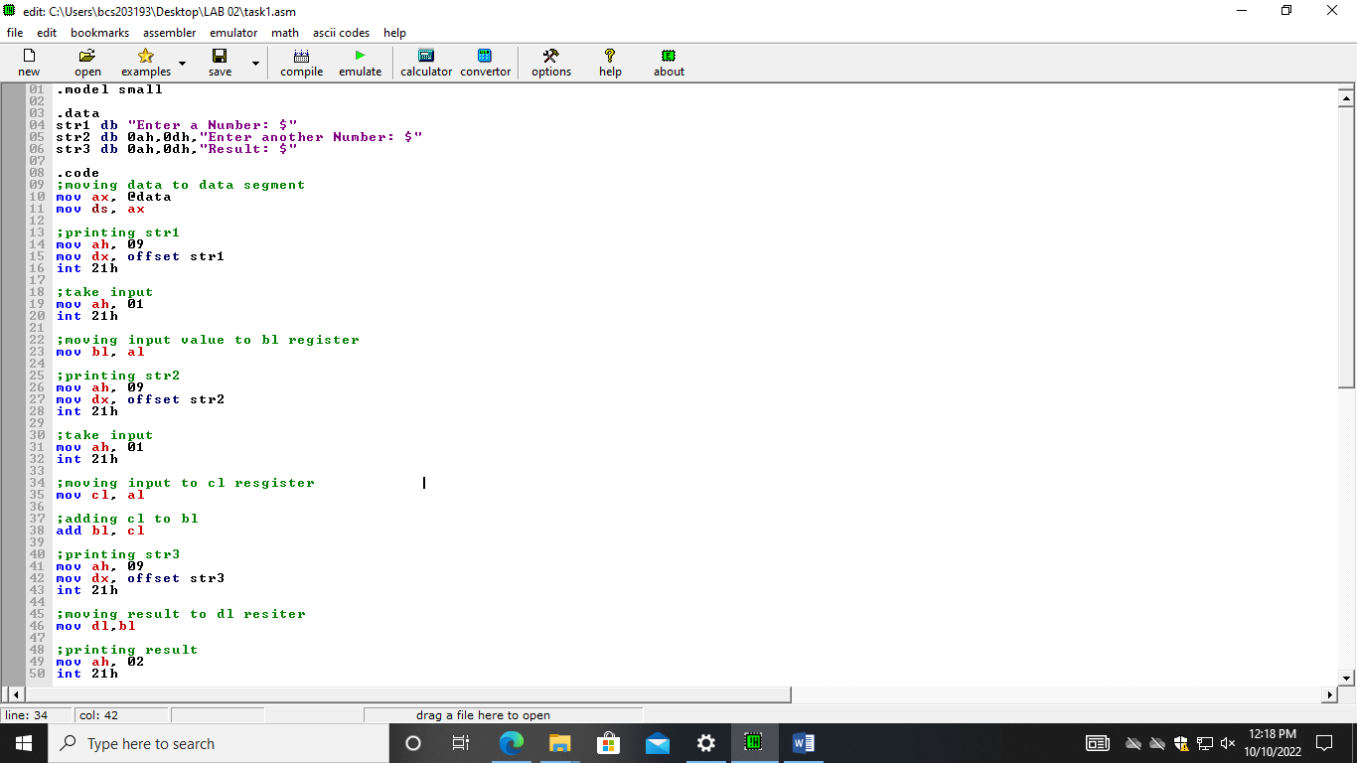

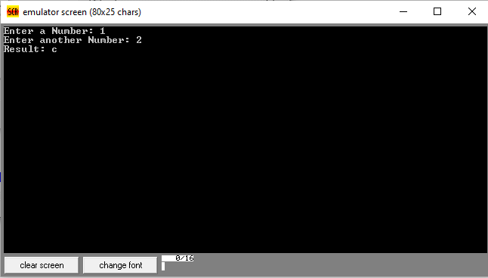

# Task 02

**Add two numbers by initializing their values in data segment. Show the result of addition on the console screen. Don’t use any variable to store variable. Do the addition operation on default register al and bl?**

## Answer:

.model small

.data

str1 db "Result: $"

val1 db 4d

val2 db 2d

.code

;moving data to data segment

mov ax, @data

mov ds, ax

;take input variable

mov ah, val1

;moving input value to bl register

mov bl, al

;take input variable

mov ah, val2

;moving input to cl resgister

mov cl, al

;adding cl to bl

add bl, cl

;printing str1

mov ah, 09

mov dx, offset str1

int 21h

;adding ASCII value

add bl, 48d

;moving result to dl resiter

mov dl,bl

;printing result

mov ah, 02

int 21h

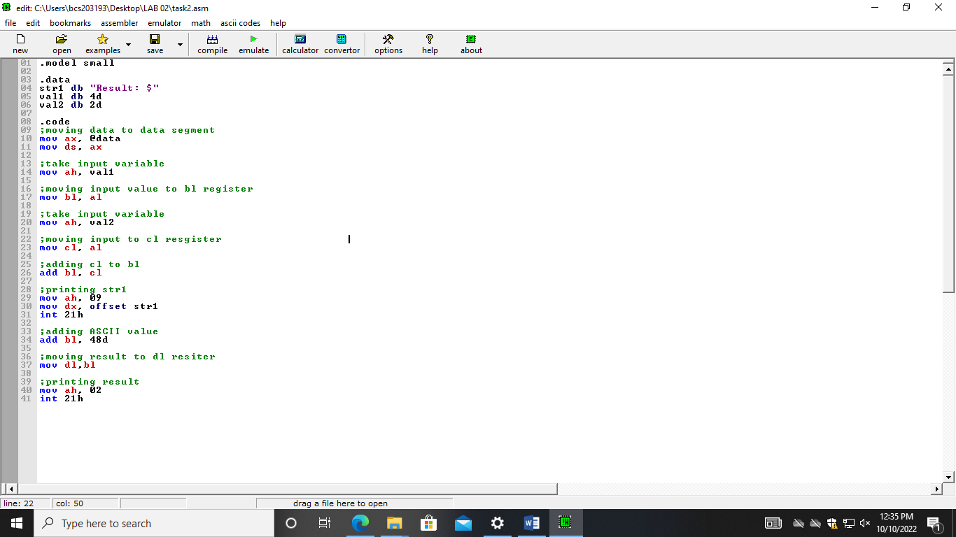

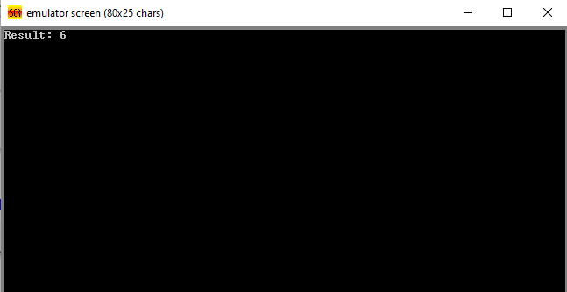

# Task 03

**Take two numbers from user and subtract their ASCII number. Show the outcome of their subtraction in decimal number. Hint: Do not convert ASCII to decimal by adding 48.**

## Answer:

.model small

.data

str1 db "Enter a Number: $"

str2 db 0ah,0dh,"Enter another Number: $"

str3 db 0ah,0dh,"Result: $"

.code

;moving data to data segment

mov ax, @data

mov ds, ax

;printing str1

mov ah, 09

mov dx, offset str1

int 21h

;take input

mov ah, 01

int 21h

;moving input value to bl register

mov bl, al

;subtracting ASCII value to bl

sub bl, 48d

;printing str2

mov ah, 09

mov dx, offset str2

int 21h

;take input

mov ah, 01

int 21h

;moving input to cl resgister

mov cl, al

;subtracting ASCII value to cl

sub cl, 48d

;subtracting cl to bl

sub bl, cl

;printing str3

mov ah, 09

mov dx, offset str3

int 21h

;moving result to dl resiter

mov dl, bl

;printing result

mov ah, 02

int 21h

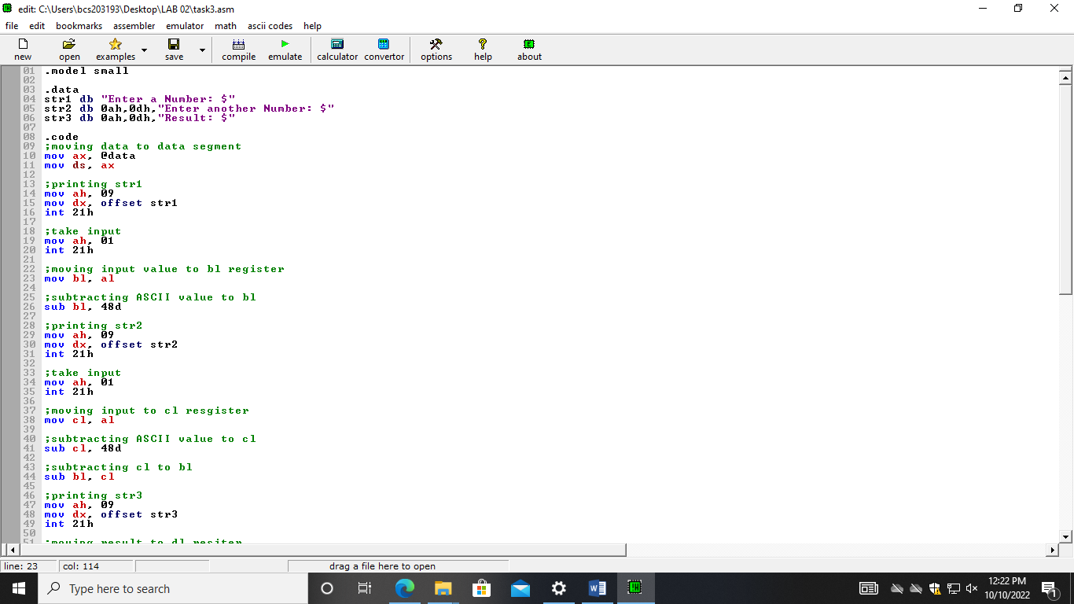

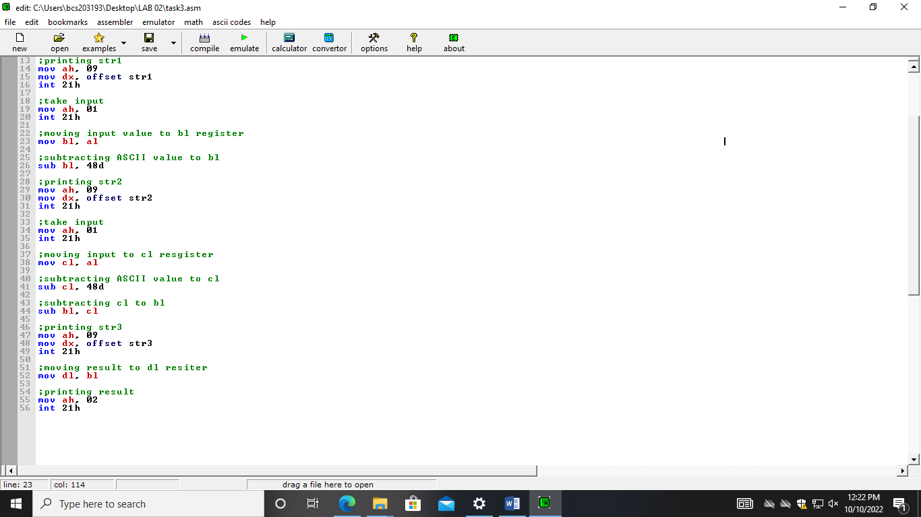

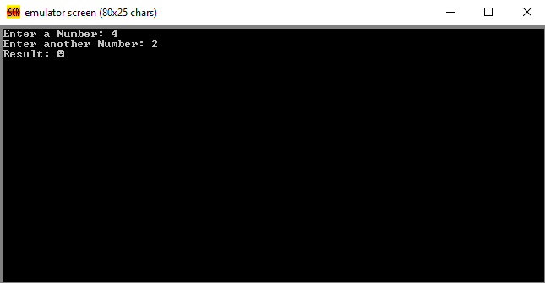

# Task 04

**Make three variables and take two values from user at runtime and store them in variable number one and two. Add first two values in variables. Take third value from user and store it in variable number 3. Third value should be of one digit and smaller than the sum of two previous values. Subtract the value in third variable from the addition result of first two variables. Display the output on the screen?**

## Answer:

.model small

.data

str1 db "Enter a Number: $"

str2 db 0ah,0dh,"Enter another Number: $"

str3 db 0ah,0dh,"Result: $"

str4 db 0ah, 0dh, "Enter third Number: $"

.code

;moving data to data segment

mov ax, @data

mov ds, ax

;printing str1

mov ah, 09

mov dx, offset str1

int 21h

;take input

mov ah, 01

int 21h

;moving input value to bl register

mov bl, al

;printing str2

mov ah, 09

mov dx, offset str2

int 21h

;take input

mov ah, 01

int 21h

;moving input to cl resgister

mov cl, al

;printing str1

mov ah, 09

mov dx, offset str4

int 21h

;take input

mov ah, 01

int 21h

;moving input value to bl register

mov dl, al

;adding dl to cl

add cl, dl

;adding cl to bl

add bl, cl

;printing str3

mov ah, 09

mov dx, offset str3

int 21h

;moving result to dl resiter

mov dl,bl

;printing result

mov ah, 02

int 21h

